ASSIGNMENT -2
Name-Rishabh Samra
Roll No-EE17S300

1. MNIST CLASSIFICATION USING CNN

Plots for given network without batchnormalization:
Accuracy attained : 97.5%
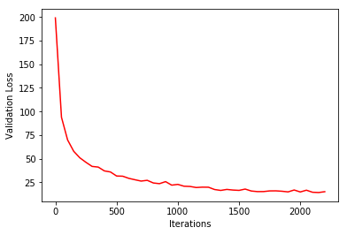
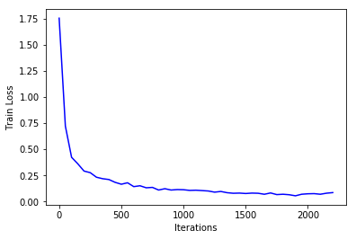

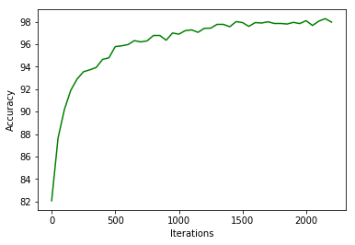

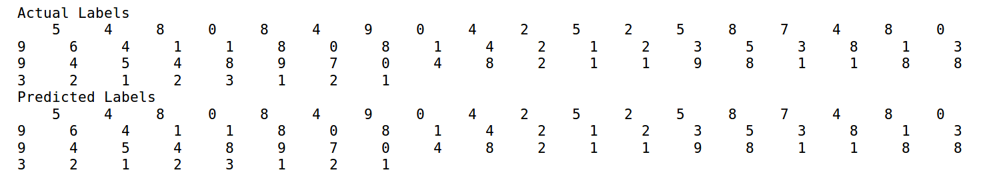

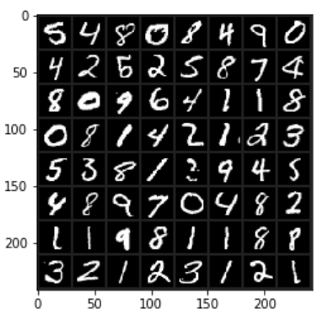

Dimensions of Input and Output at each Layer:

LAYERS | OUTPUT  DIMENSION | PARAMETERS | NEURONS
Input Layer | 28*28*1 | 0 | 784
Conv1 | 28*28*32 | 288(W)+32(B) = 320 | 25088
Maxpool 1 | 14*14*32 | 0 | 6272
Conv2 | 14*14*32 | 9216(W)+32(B) = 9248 | 6272
Maxpool 2 | 7*7*32 | 0
Fully Connected 1 | 500*1 | 784000(W)+500(B)=784500 | 500
Fully Connected 2 | 10*1 | 5000(W)+10(B) = 5010 | 10

Total No of Parameters = 799078
No of parameters of Convolution layer = 31360
No of parameters of fully connected layer = 789510

Total No of Neurons = 38926
Neurons in Convolution Layer = 31360
Neurons in Fully Connected Layer = 510

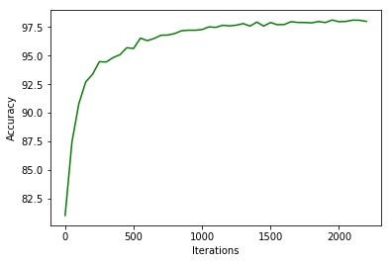
BATCH NORMALIZATION:

There is not much improvement in test accuracy but batch normalization seems to have faster convergence as can be seen from plot of the test accuracy in two cases.

2.Visualizing Convolutional Neural Networks

Activations of
LAYER 1 LAYER2
Filter 1
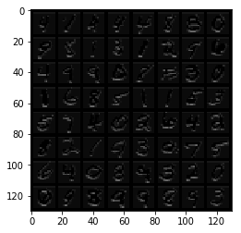
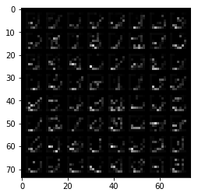

Filter 5

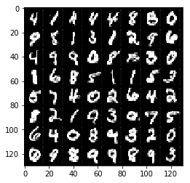
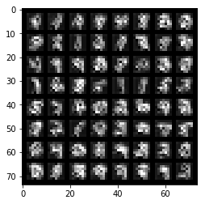

Filter 8
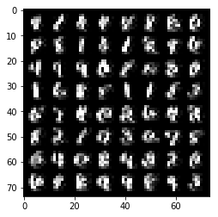
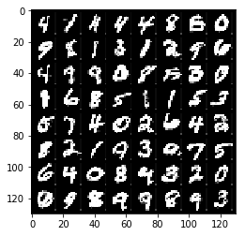

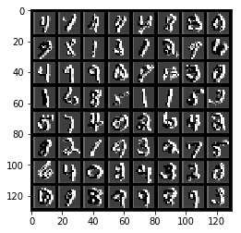
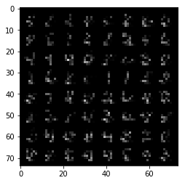
Filter -15

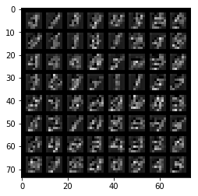
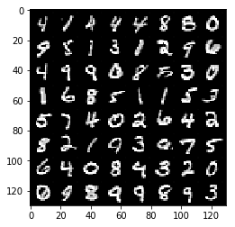
Filter 25

Filter 31
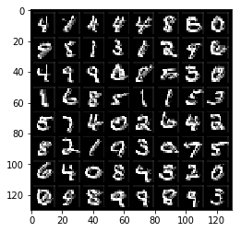
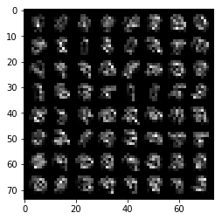

The outer layer gives more generic information about the image.As we go deeper inside it detects more abstract features of the digit.

OCCLUDING IMAGES

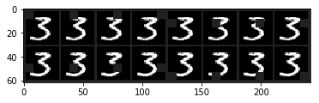

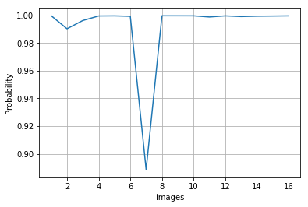
We can observe at 7 image,there is decrease in probability of the predicted class.

3. Adversarial Examples

1.Non targeted attack

0 1 2 3

4 5 6 7

8 9

All images are predicted with confidence score of 0.8
The cost function is decreasing with iterations.

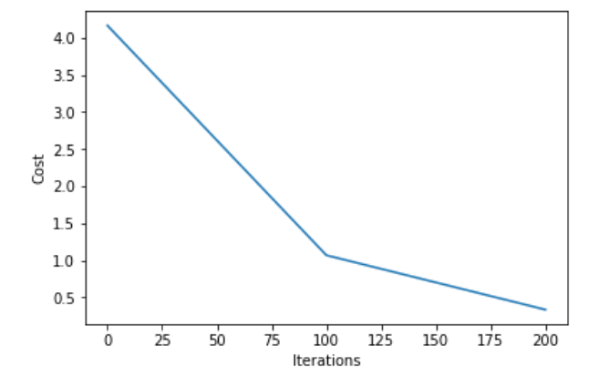

No the generated image doesn’t look like a number because the randomly generated image is trying to fool a network by enabling it to predict some particular class with highest probability

2.Targeted Attack

Original Images

Changed Images

All images are being predicted as 9.Yes targeted image looks like a number.

3. Adding Noise:

Generated Adversarial Image:

Noise:

